PROJECTILE MOTION INVESTIGATION 2021

ANSWER KEY MARKS: /35

Note: Mass of toy missile = 5.842 g Distance between lines on scale: 10cm (0.10m) Strobe setting: 10 Hz (0.1 sec between flashes.)

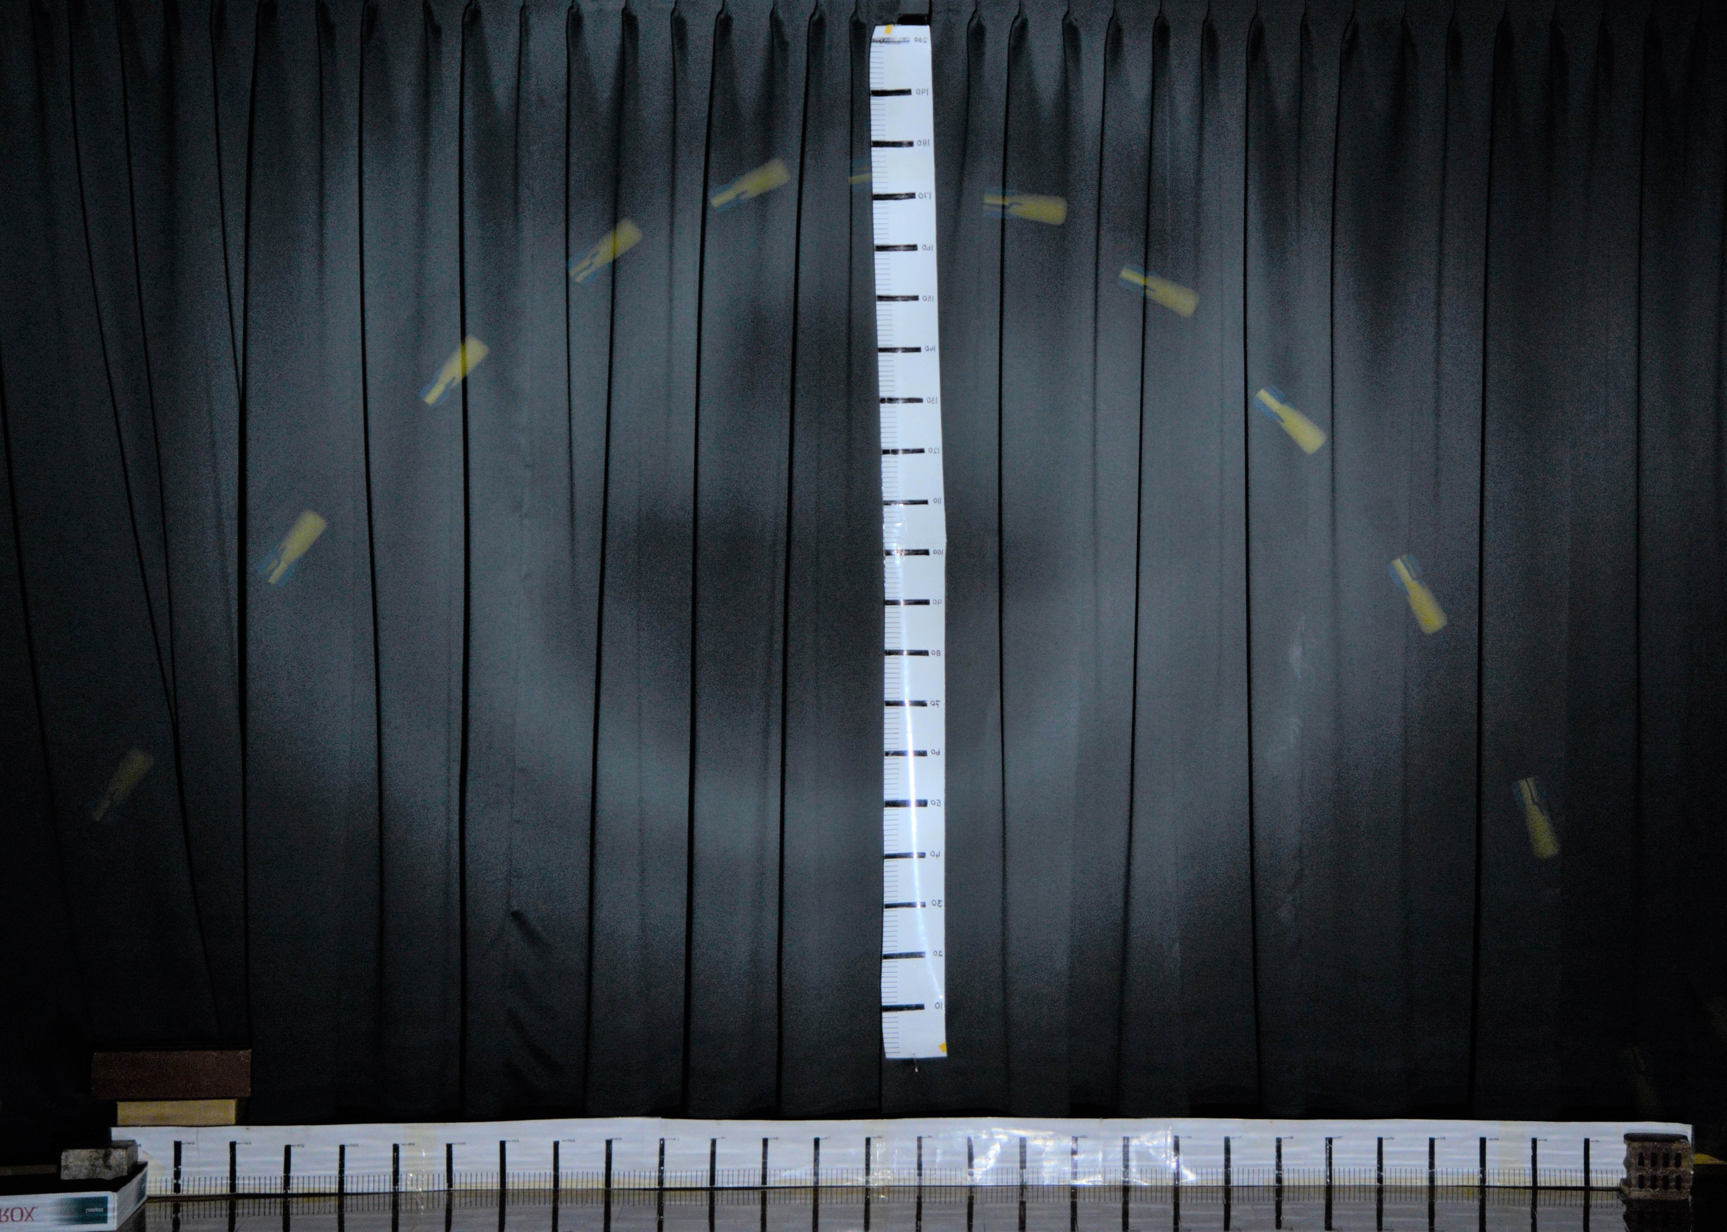

1.33mm

1.36mm

0.43mm

Total horizontal displacement = 2.68 +- 0.02 m
Total flight time = 1.0s
(2 marks)

- Determine the initial horizontal velocity of the projectile. Use the first two images. (Lines have been drawn from the top of the first projectile image). (1 mark)
u_{h} = s/t = 0.32 / 0.1 = 3.2 ms⁻¹

- Measure the take-off angle: 58 (+-1) degrees. (1 mark)

- Using this value and your answer from questions 1.0 and 2.0, calculate the initial total take-off velocity (u) and hence calculate the magnitude of the initial vertical velocity (u_{v}). (2 marks)

U_{h} = UcosӨ so U = U_{h}/cosӨ = 3.2/cos58 = 6.04 ms⁻¹

U_{v} = UsinӨ = 6.04 sin58 = 5.12 ms⁻¹

- From your answers to questions 1.0 and 3.0, determine the theoretical range and maximum height of the projectile. (4 marks)

Theoretical range = u_{h} x t_{tot} = 3.2 ms⁻¹ x 1.0s = 3.2m (1)

Theoretical vertical height:

v² = u² + 2as (1) (This method)
0 = (5.12)² + 2(-9.8ms⁻²) s (1)
s = 1.34m (1)

NB: if s = ut + ½at² and t = 0.50 used, max of 2 marks since the t = 1.0/2s is not a valid assumption (even though the answer is almost identical).

- Using your answers to 4.0, sketch the theoretical curve on top of the photograph.
(1) Ht according to ans Q4, (1) Range as per ans Q 4 (2 marks)

- From the photograph, determine the final horizontal velocity of the projectile.
(Use the last two images on the right). (2 marks)

S_{H} = 0.22 +- 0.01 m (from photo) (1)

v_{H} = 0.22m / 0.1s = 2.2ms⁻¹ (1)

- Using u_{h} and your answer from 6.0, calculate the change in horizontal velocity and hence the average horizontal deceleration over the total time of the flight
(2 marks)

∆v = 2.2 – 3.2 = - 1.0 ms⁻¹ (1)

a_{H} = ∆v/t = - 1.0 ms⁻¹ / 1.0 s = - 1.0 ms⁻² (1)

- Using your answer to 7.0, calculate the retarding horizontal force on the projectile. Express your answer to the appropriate number of significant figures. (4 marks)

F_{H} = 1.0 ms⁻² x 0.005842 kg = 5.8 x 10⁻³ N LEFT
(1) (1) Dir’n (1)

Accept – 5.8 x 10⁻³ N to show direction 2 sig figs (1)

- From the photograph, determine the “final” vertical displacement and hence calculate the final vertical velocity of the projectile (use the last two images on the right).

(2 marks)
∆s = 0.43 +- 0.01 m (1)
OR: v² = (5.12)² + 2(-9.8)(-0.20)

v = 5.48ms⁻¹

∆v = - 0.43m / 0.1s = - 4.3 ms⁻¹ (1)

- Using the initial vertical velocity as zero, your answer from 9.0 and the displacement from the highest point to the last image, calculate the downward acceleration on the projectile while it is falling.
(3 marks)

s = 1.36 +- 0.01m (1)

v² = u² + 2as
(-4.3)² = 0 + 2a(-1.36) (1)
a_{v} = - 6.8 ms⁻² (1)

- Knowing that the downward acceleration should be 9.8 ms⁻², from your answer to 10.0, calculate the upward force on the projectile due to air friction
Express your answer to the appropriate number of significant figures (4 marks)

∆a = 9.8 – 6.8 = 3.0 ms⁻² up (1)

F_{V} = ma = 3.0 x 0.005842 kg = 1.8 x 10⁻² N UP
(1) Dir’n (1)

2 sig figs (1)

- Using the photo below, determine Max’s average speed. (4 marks)

Show on the photo from where you have taken your measurements.

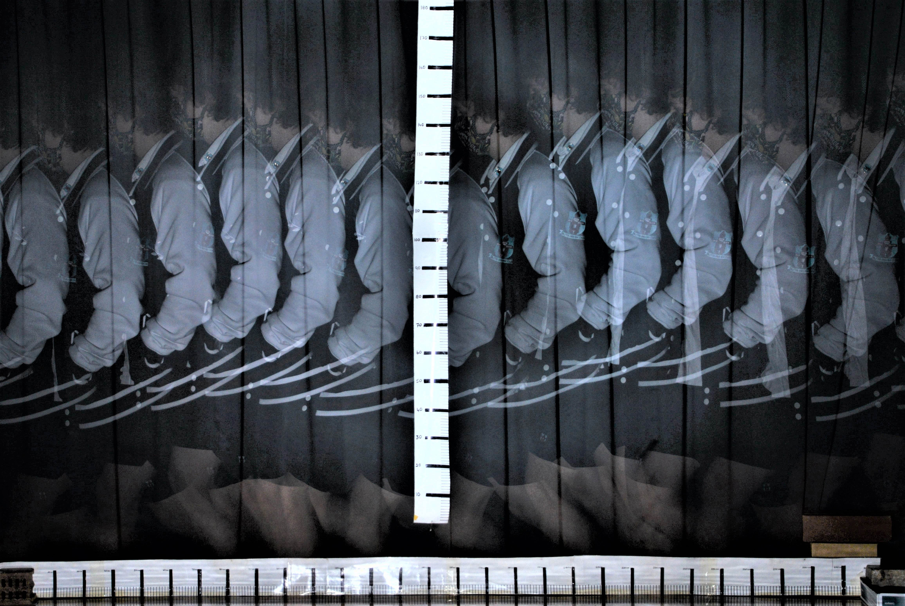

S= 2.47 m t = 1.0 s V = s/t = 2.47 ms⁻¹

1 mark: lines shown with at least 4 images (0.3s) (A good reference point in each image is important for accuracy).
1 mark: time
1 mark: value of s
1 mark: correct calc based on s and t determined

- The above calculation may be in error due to a systematic error in the design of the experiment. What is the problem and what effect would it have on your answer? Allow: strobe may be not exactly 0.1 sec, potentially minor problem so only 1 mark. “Paralax Error” : 1 mark IF a reasonable effort made to explain.
Don’t allow any examples that are clearly RANDOM errors.
(2 marks)
The person should have been asked to walk as close to the scales as possible, this may not have been the case. (1)

(The measured distance should be smaller.) The calculated speed would be too HIGH. (1)

